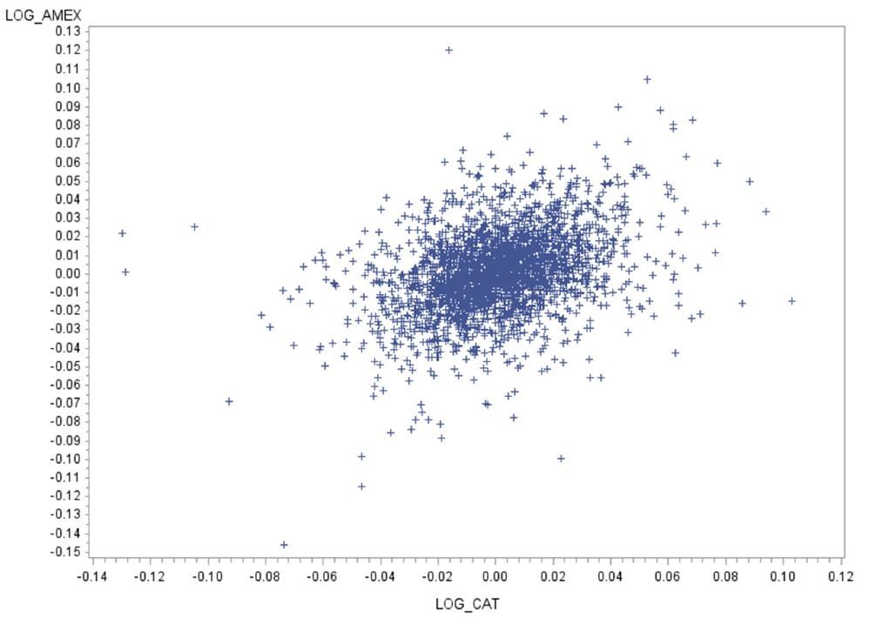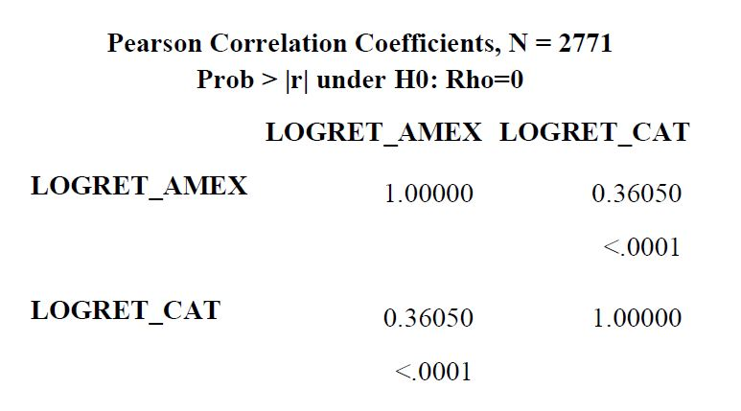Question 5

H0: ρ=0; Ha: ρ≠0. ρ is the correlation between log returns of AMEX and CAT.

As can be seen, sample correlation coefficient between log returns of AMEX and CAT, ρ=0.36050, is significantly greater than 0, and p<0.0001<0.05=α, for null hypothesis H0: ρ=0. These two evidences lead us to reject H0 where the two log returns are not correlated. On the other hand, the alternative hypothesis, Ha: ρ≠0, cannot be rejected, and there is very likely a positive correlation between log returns of AMEX and CAT.